Paper Title

Author Name¹, Author Name²
¹Department, University, City, State, Country-Pincode
²Department, University, City, State, Country-Pincode

Abstract—This electronic document is a “live” template and already defines the components of your paper [title, text, heads, etc.] in its style sheet. Do Not Use Special Characters, Symbols, or Math in Paper Title or Abstract.

Keywords— Enter key words or phrases in alphabetical order, separated by colon.

Introduction
This document is a template. An electronic copy can be downloaded from the Journal website. For questions on paper guidelines, please contact the journal publications committee as indicated on the journal website. All title and author details must be in single-column format and must be centered.
Every word in a title must be capitalized except for short minor words such as “a”, “an”, “and”, “as”, “at”, “by”, “for”, “from”, “if”, “in”, “into”, “on”, “or”, “of”, “the”, “to”, “with”.
Author details must not show any professional title (e.g. Managing Director), any academic title (e.g. Dr.) or any membership of any professional organization (e.g. Senior Member IEEE).

Page Layout
An easy way to comply with the conference paper formatting requirements is to use this document as a template and simply type your text into it.
- Page Layout
Your paper must use a page size corresponding to A4 which is 8.27" wide and 11.69" long. The margins must be set as follows:
- Top = 0.75"
- Bottom = 1.18"
- Left = Right = 0.51"
The body content of the paper must be in Two Column format with column size 3.5” and 0.25” spacing.
- Title and Author Details
Title must be in 24 pt Regular font. Author name must be in 14 pt Regular font. Author affiliation must be in 10 pt Regular font. Email address must be in 10 pt Regular font.

Figures and Tables
Place figure captions below the figures; place table titles above the tables. If your figure has two parts, include the labels “(a)” and “(b)” as part of the artwork. Please verify that the figures and tables you mention in the text actually exist. Use the abbreviation “Fig.” even at the beginning of a sentence. If the size of Figure or Table is more than the column size, the same may be adjusted in single column format without disturbing rest of the content.

Math
If you are using Word, use either the Microsoft Equation Editor or the MathType add-on (http://www.mathtype.com) for equations in your paper (Insert | Object | Create New | Microsoft Equation or MathType Equation). “Float over text” should not be selected.

Equations Style
Number equations consecutively with equation numbers in parentheses flush with the right margin, as in (1). First use the equation editor to create the equation. Then select the “Equation” markup style. Press the tab key and write the equation number in parentheses. To make your equations more compact, you may use the solidus ( / ), the exp function, or appropriate exponents. Use parentheses to avoid ambiguities in denominators. Punctuate equations when they are part of a sentence, as in
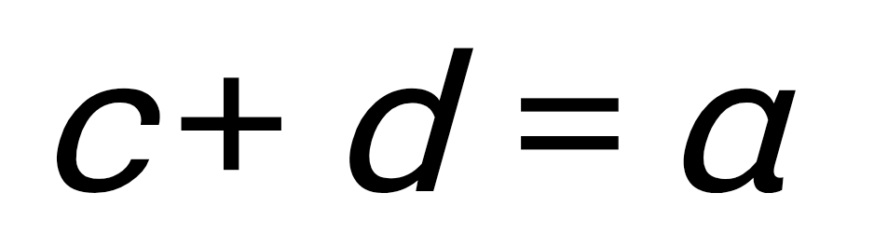
Be sure that the symbols in your equation have been defined before the equation appears or immediately following. Italicize symbols (T might refer to temperature, but T is the unit tesla). Refer to “(1),” not “Eq. (1)” or “equation (1),” except at the beginning of a sentence: “Equation (1) is ....”

TABLE I. Table styles.
S. No. | Table Column Head (in Time New Roman)
 | Subhead | Subhead | Subhead
1

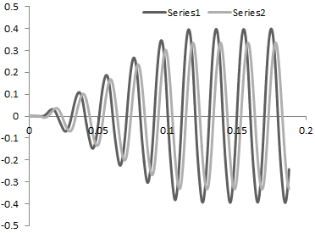
Fig. 1. Example of a figure caption.

Units
Use either SI (MKS) or CGS as primary units. (SI units are strongly encouraged.) English units may be used as secondary units (in parentheses). This applies to papers in data storage. For example, write “15 Gb/cm² (100 Gb/in²).” An exception is when English units are used as identifiers in trade, such as “3½-in disk drive.” Avoid combining SI and CGS units, such as current in amperes and magnetic field in oersteds. This often leads to confusion because equations do not balance dimensionally. If you must use mixed units, clearly state the units for each quantity in an equation.
The SI unit for magnetic field strength H is A/m. However, if you wish to use units of T, either refer to magnetic flux density B or magnetic field strength symbolized as µ₀H. Use the center dot to separate compound units, e.g., “A·m².”

Other Recommendations
Use one space after periods and colons. Hyphenate complex modifiers: “zero-field-cooled magnetization.” Avoid dangling participles, such as, “Using (1), the potential was calculated.” [It is not clear who or what used (1).] Write instead, “The potential was calculated by using (1),” or “Using (1), we calculated the potential.”
Use a zero before decimal points: “0.25,” not “.25.” Use “cm³,” not “cc.” Indicate sample dimensions as “0.1 cm ⋅ 0.2 cm,” not “0.1 ⋅ 0.2 cm².” The abbreviation for “seconds” is “s,” not “sec.” Do not mix complete spellings and abbreviations of units: use “Wb/m²” or “webers per square meter,” not “webers/m².” When expressing a range of values, write “7 to 9” or “7-9,” not “7~9.”
A parenthetical statement at the end of a sentence is punctuated outside of the closing parenthesis (like this). (A parenthetical sentence is punctuated within the parentheses.) In American English, periods and commas are within quotation marks, like “this period.” Other punctuation is “outside”! Avoid contractions; for example, write “do not” instead of “don’t.” The serial comma is preferred: “A, B, and C” instead of “A, B and C.”

Copyright Form
An IRJAES copyright form should accompany your final submission. You can get a pdf version at http://www.irjaes.com. Authors are responsible for obtaining any security clearances.

Editorial Policy
The submitting author is responsible for obtaining agreement of all coauthors and any consent required from sponsors before submitting a paper. It is the obligation of the authors to cite relevant prior work. Authors of rejected papers may revise and resubmit them to the journal again.

Conclusion
A conclusion section is not required. Although a conclusion may review the main points of the paper, do not replicate the abstract as the conclusion. A conclusion might elaborate on the importance of the work or suggest applications and extensions.
Appendix
Appendixes, if needed, appear before the acknowledgment.

Acknowledgment
The preferred spelling of the word “acknowledgment” in America is without an “e” after the “g.” Avoid the stilted expression “one of us (R. B. G.) thanks ...”. Instead, try “R. B. G. thanks...”. Put sponsor acknowledgments in the unnumbered footnote on the first page.
References
NOTE: Do not use “et al.”
Format for books:
- J. L. Author, “Title of chapter in the book,” in Title of His Published Book, xth ed. City of Publisher, Country if not
- USA: Abbrev. of Publisher, ch. x, sec. x, pp. xx–xx, year.
Examples:
- G. O. Young, “Synthetic structure of industrial plastics,” in Plastics, 2nd ed., vol. 3, J. Peters, Ed. New York: McGraw-Hill, pp. 15–64, 1964.
- W.-K. Chen, Linear Networks and Systems. Belmont, CA: Wadsworth, pp. 123–135, 1993.

Format for periodicals:
- J. L. Author, “Name of paper,” Abbrev. Title of Periodical, vol. x, no. x, pp. xx-xx, year.
Examples:
- J. U. Duncombe, “Infrared navigation—Part I: An assessment of feasibility,” IEEE Transactions Electron Devices, vol. ED-11, no. 1, pp. 34–39, 1959.
- E. P. Wigner, “Theory of traveling-wave optical laser,” Physical Review, vol. 134, pp. A635–A646, 1965.
- E. H. Miller, “A note on reflector arrays,” IEEE Transactions on Antennas and Propagation, to be published.

Format for reports:
- J. L. Author, “Title of report,” Abbrev. Name of Co., City of Co., Abbrev. State, Rep. xx, year.
Examples:
- E. E. Reber, R. L. Michell, and C. J. Carter, “Oxygen absorption in the earth’s atmosphere,” Aerospace Corp., Los Angeles, CA, Tech. Rep. TR-0200 (4230-46)-3, 1988.
- J. H. Davis and J. R. Cogdell, “Calibration program for the 16-foot antenna,” Elect. Eng. Res. Lab., Univ. Texas, Austin, Tech. Memo. NGL-006-69-3, 1987.

Format for handbooks:
- Name of Manual/Handbook, x ed., Abbrev. Name of Co., City of Co., Abbrev. State, pp. xx-xx, year.
Examples:
- Transmission Systems for Communications, 3rd ed., Western Electric Co., Winston-Salem, NC, pp. 44–60, 1985.
- Motorola Semiconductor Data Manual, Motorola Semiconductor Products Inc., Phoenix, AZ, 1989.

Format for journals
- Author, “Title of paper,” Journal, vol. x, issue x, pages xx-xx, year.
Example:
- R. J. Vidmar. “On the use of atmospheric plasmas as electromagnetic reflectors,” IEEE Transactions on Plasma Sciences, vol. 21, issue 3, pp. 876–880, 1992.

Format for conference proceedings (published):
- J. L. Author, “Title of paper,” in Abbreviated Name of Conference, City of Conf., Abbrev. State (if given), pp. xx-xx, year.
Example:
- D. B. Payne and J. R. Stern, “Wavelength-switched pas- sively coupled single-mode optical network,” in Proceedings IOOC-ECOC, pp. 585–590, 1985.
Example for papers presented at conferences (unpublished):
- D. Ebehard and E. Voges, “Digital single sideband detection for interferometric sensors,” presented at the 2nd International Conference Optical Fiber Sensors, Stuttgart, Germany, 1984.

Format for theses (M.S.) and dissertations (Ph.D.):
- J. L. Author, “Title of thesis,” M.S. thesis, Abbrev. Dept., Abbrev. Univ., City of Univ., Abbrev. State, year.
- J. L. Author, “Title of dissertation,” Ph.D. dissertation, Abbrev. Dept., Abbrev. Univ., City of Univ., Abbrev. State, year.
Examples:
- J. O. Williams, “Narrow-band analyzer,” Ph.D. dissertation, Department of Electrical Engineering, Harvard University, Cambridge, MA, 1993.
- N. Kawasaki, “Parametric study of thermal and chemical nonequilibrium nozzle flow,” M.S. thesis, Department of Electronic Engineering, Osaka University., Osaka, Japan, 1993.

Format for online patents:
- Name of the invention, by inventor’s name (year, month day), Patent Number, year. Available: site/path/file
Example:
- Musical toothbrush with adjustable neck and mirror, by L.M.R. Brooks, Patent D 326 189, 1992.

Format for patents:
- J. L. Author, “Title of patent,” U.S. Patent x xxx xxx, day, year.
Example:
- G. Brandli and M. Dick, “Alternating current fed power supply,” U.S. Patent 4 084 217, 1978.

Format for the most common types of unpublished references:
- J. L. Author, private communication, year.
- J. L. Author, “Title of paper,” unpublished.
- J. L. Author, “Title of paper,” to be published.
Examples:
- A. Harrison, private communication, 1995.
- B. Smith, “An approach to graphs of linear forms,” unpublished.
- A. Brahms, “Representation error for real numbers in binary computer arithmetic,” IEEE Computer Group Repository, Paper R-67-85.

